|  |  |
| --- | --- |
| Team ID | PNT2022TMID13904 |
| Project Name | CONTAINMENT ZONE ALERTING |

# SETUP MOBILE APPLICATION ENVIRONMENT ENABLE LOCATION SERVICES TO THE APPLICATION

In the future, it will be possible for the user to enable location services, so that the application can automatically inform the user about the nearest event. Location services can be enabled for the whole application in the settings of the phone.

**CODE:**

private void getLocationPermission() {

Log.d(TAG, "getLocationPermission: getting location permissions");

String[] permissions =

{Manifest.permission.ACCESS_FINE_LOCATION, Manifest.permission.ACCESS_COARSE_LOCATION};

if (ContextCompat.checkSelfPermission(this.getApplicationContext(),

FINE_LOCATION) ==

PackageManager.PERMISSION_GRANTED) { if

(ContextCompat.checkSelfPermission(this.getApplicationContext(), COURSE_LOCATION) ==

PackageManager.PERMISSION_GRANTED) {

mLocationPermissionsGranted = true; initMap();

} else {

ActivityCompat.requestPermissions(this, permissions, LOCATION_PERMISSION_REǪUEST_CODE);

}

} else {

ActivityCompat.requestPermissions(this, permissions, LOCATION_PERMISSION_REǪUEST_CODE);

}

}

// HANDLE REǪUEST PERMISSION RESULT

// ONCE

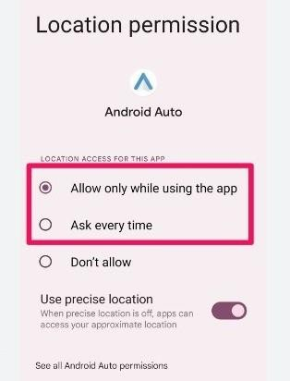

**FEATURES:**

1. **CHECK THE DEPARTURE TIMES OF THE NEXT TRAINS AT YOUR NEAREST STATION**
2. **CHECK THE DIRECTIONS OF THE TRAINS AND FIND OUT WHICH ONE IS GOING TO YOUR DESTINATION**
3. **CHECK THE STATUS OF THE TRAINS**
4. **CHECK THE MAP OF THE METRO**
5. **CHECK THE DIRECTIONS OF THE STATIONS AND THE DISTANCE FROM YOUR CURRENT LOCATION**
6. **CHECK THE LIST OF THE STATIONS IN PARIS METRO**
7. **CHECK THE DIRECTIONS OF THE STATIONS AND FIND OUT WHICH ONE IS GOING TO YOUR DESTINATION**
8. **CHECK THE STATUS OF THE STATIONS**
9. **CHECK THE LIST OF THE STATIONS IN PARIS METRO**
10. **CHECK THE DIRECTIONS OF THE STATIONS AND FIND OUT WHICH ONE IS GOING TO YOUR DESTINATION**

